ANIKA

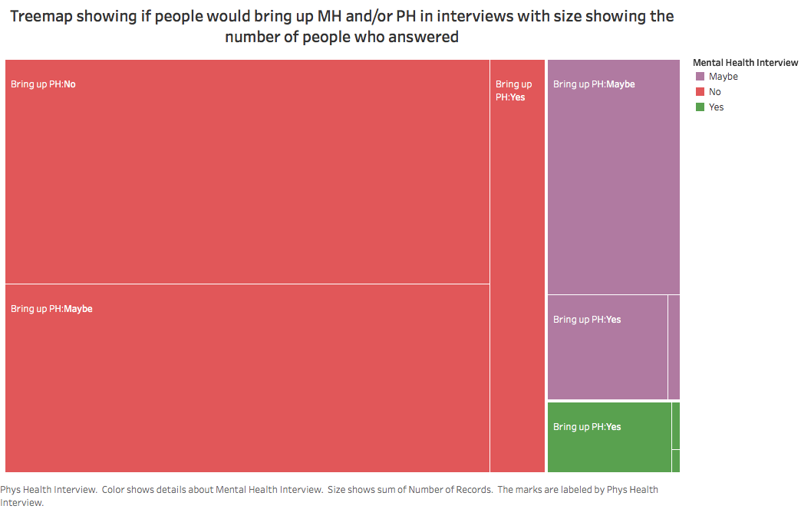

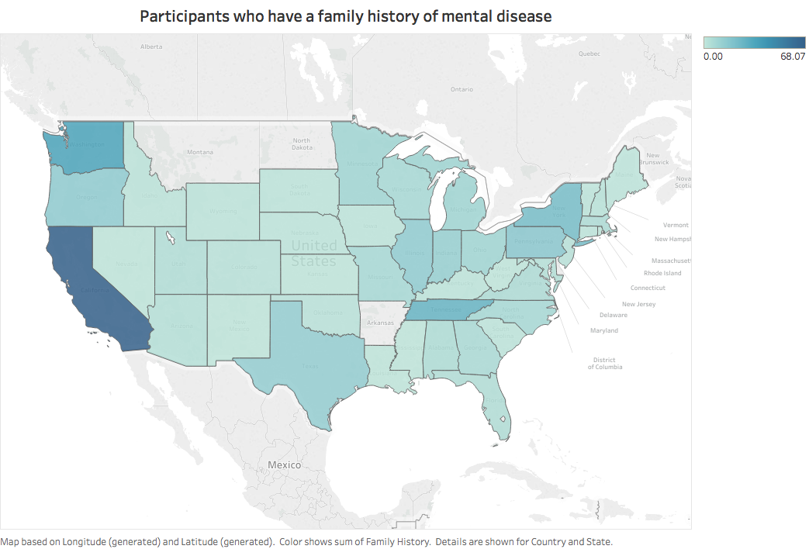

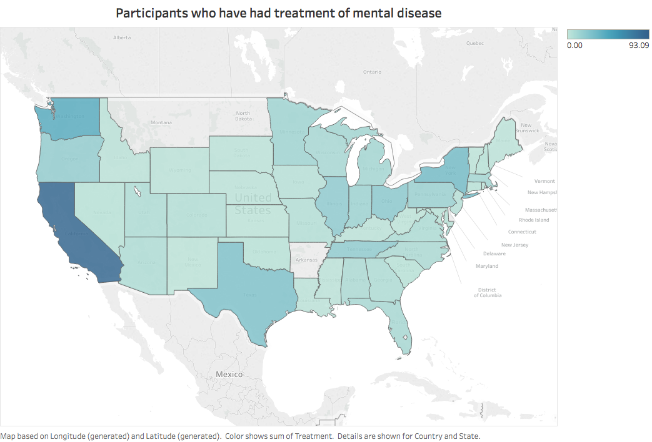

I converted all the yes’s for treatments to 1 and all the no’s for treatments to 0. I then graphed the data on a map using Tableau so the graph would show the sum of yes’s. I did the same thing for family history. I made 2 graphs to show see if there was a similar distribution of family history and treatment between the states. Based on the graphs there does seem to be a very similar distribution in each state between treatment and family history. The only obvious difference is that in TN there were more responses that had family history than treatment.

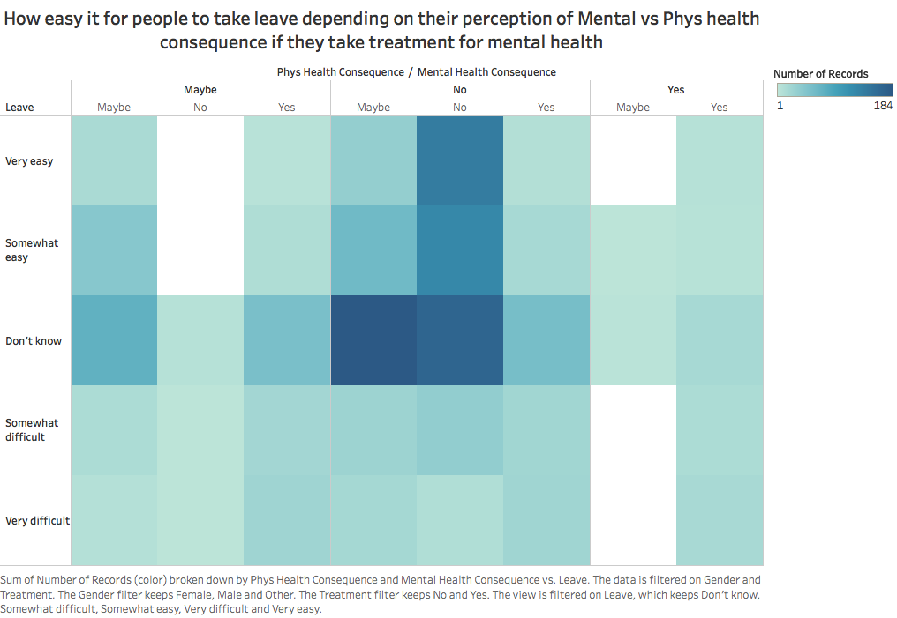

I made a heat map showing how easy people who take treatment for mental illness thought they could leave work because of a mental health issue depending on if they thought there would be a consequence for discussing mental health and/or physical health with their employee. I had color show they number of responses.

The heat map shows that the majority of people who didn’t know if they could take leave didn’t think there was physical health consequence and either said no or maybe to a mental health consequence. For people who said it would be very easy to take leave, most answered no to both physical and mental health consequence. Few people said that it would be very difficult to taking leave. Not many people answered saying there would be a physical consequence but if they did answer that, most people said there would be a mental health consequence and 0 people answered then said there wouldn’t be a mental health consequence.

**Deepak**

Contingency Map showing how likely Employees are willing to discuss a Mental Health issue with Coworkers/Supervisors

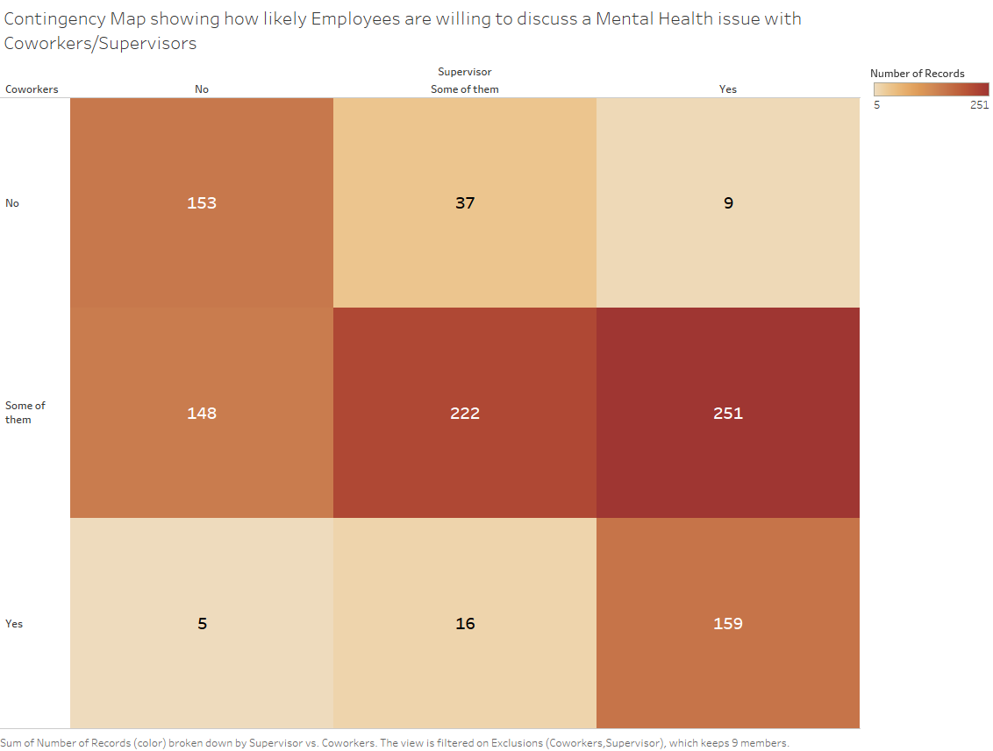

We created a heatmap using Tableau to show how likely employees are willing to discuss a mental health issue with their co-workers or supervisors.

The graph shows that most responders who discussed mental health issues with their supervisors, would discuss the same with some of their co-workers. Responders who discuss about mental health issues with their supervisors and do not discuss the same with their co-workers, and vice-versa, were very rare.

Graph showing Age/Gender distribution of people who have observed negative Mental Health Consequences at the Workplace

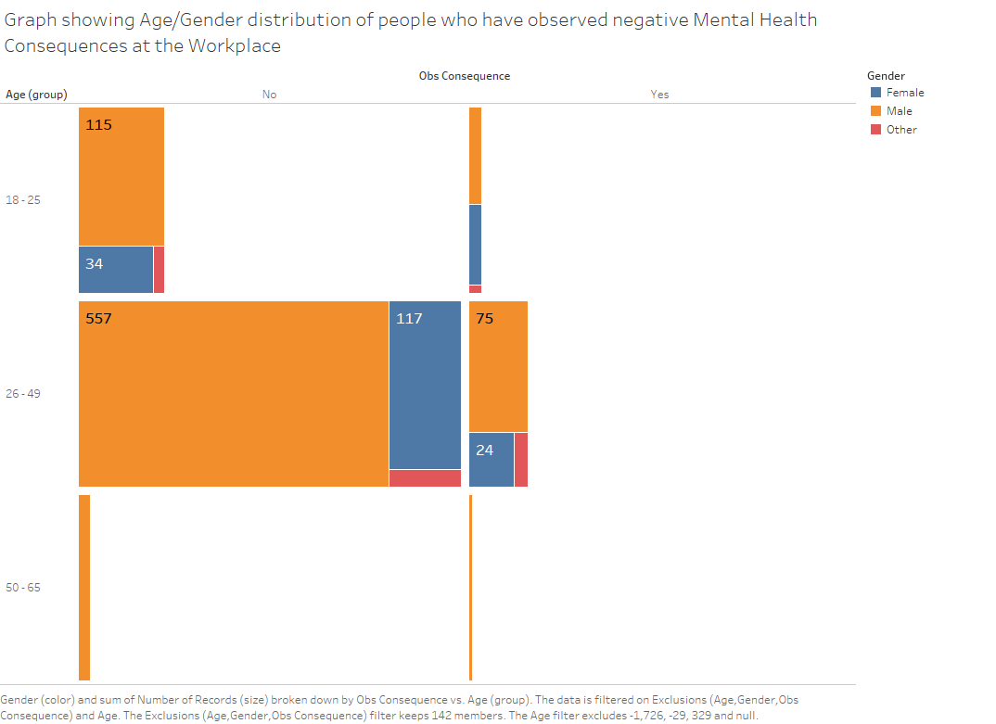

We created this graph using Tableau to show the age and gender distribution of people who have observed negative mental health consequences at the workplace.

The graph is a treemap distribution, with the top hierarchy being age group, and the sub-divisions being gender.

It shows that majority of responders did not observe negative mental health consequences at the workplace, with most of them being male and in the age group of 26-49.

Kripa

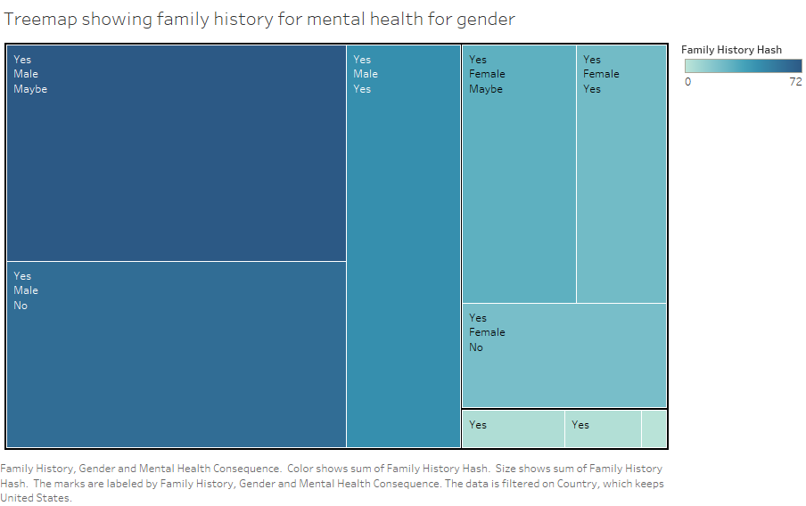

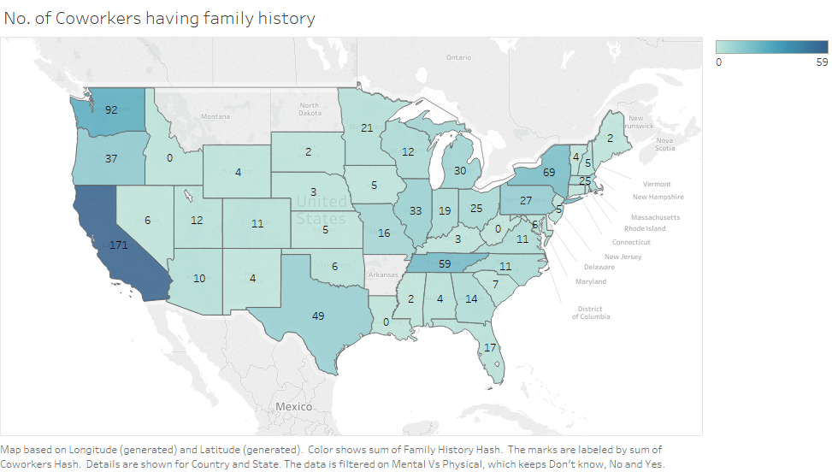

I am trying to show the graph for the no. of co workers per state who have the family history of mental health. I first converted, all the yes’s for Family history to 1 and all the no’s for Family history to 0. Then, I graphed it using tableau. The graph shows the marks which are labeled by the sum of the Coworkers, Color shows sum of the Family history and the data is detailed for Country and State.

